Launching the program

The "Client Application" module of the "Agricultural Statistical Register" component of the IIS "e-Statistics" is designed to enter data on the household book and the Book of Accounts for peasant or farm enterprises.
To launch the client application, double-click the left mouse button on the icon 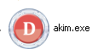 on the desktop of your computer.

2.4.1.2 Workspace

After starting the program, a window will open for entering a username and password. These login and password are required to prevent unauthorized access to your e-book of economic accounting. Login and password are provided by the Regional Department of Statistics (RUS).
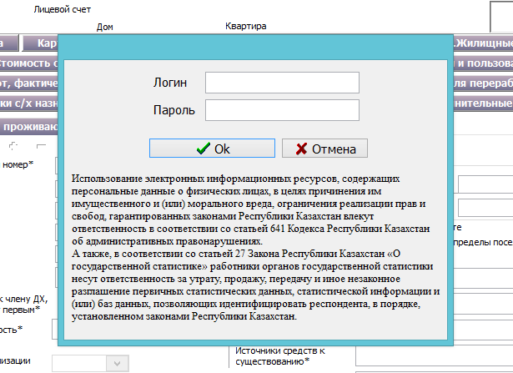

After you enter your username and password, a window will open with a choice of period and settlement.
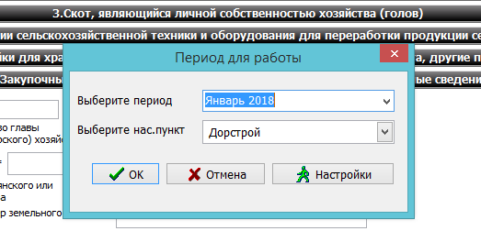

Select the period, settlement and click on the "OK" button. You can also enter the user's personal data. When you click on the "Settings" button, a form for entering personal data will open.
In the "Personal settings" window, if necessary, fill in the fields "Name of the rural district", "FULL NAME of akim". The field "CATO" is selected from the list. The "CATO" list is displayed when the "Select" button is pressed.
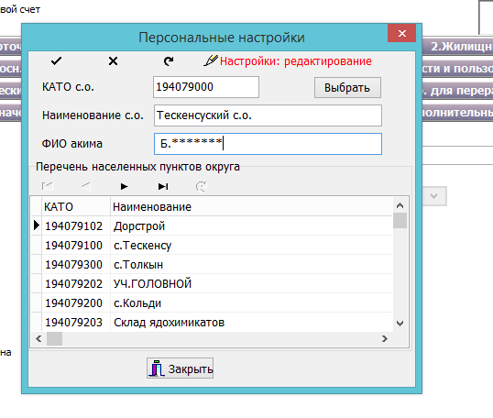
Exit from the "Personal settings" window is carried out using the "Close" button.
After the user closes the "Personal data" window and the "Period selection" window, the main program window will open. The program window consists of the following elements:
Main menu of the program;
Toolbar, with buttons for quick access to menu commands;
A working window that allows you to enter data on the Household Book of Accounts and the Book of Accounts of Peasants and / or Farms;
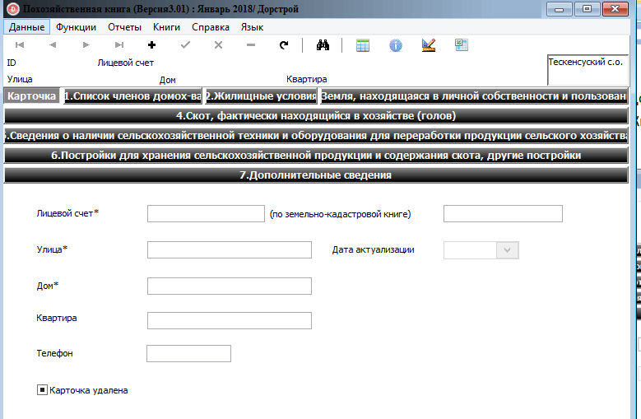

The main menu is presented in the form of a line with a list of mode names. Each mode consists of a sub-menu that is included in this mode.
The toolbar consists of the following buttons:
 | Начало | Jump to the first record
 | Конец | Jump to the last entry
 | Предыдущая | Jump to the previous record
 | Следующая | Jump to the next record
 | Добавить | Add new data
 | Сохранить | Save data
 | Отменить | Undo actions
 | Удалить | Delete data
 | Обновить | Update the data
 | Поиск | Search by specified parameters
 | Реестр записей | View all data in a table view
 | История значений | View primary data
 | Проверка FLC | Checking data for format-logical control
 | Экспорт в Excel | Export data for the rural district to Excel

Main menu
The main menu consists of the following items:
- Data;
- Functions;
- Reports;
- Books;
- Reference;
- Language.
Menu item "Data"
The Data menu item consists of standard functions (jump to start, jump to end, jump to the previous record, jump to the next record, add, save, cancel, delete) which duplicate the toolbar.
Menu item "Functions"
The menu item Functions consists of the following sub-items:
- Search - when this function is pressed, the following window will open to the user:
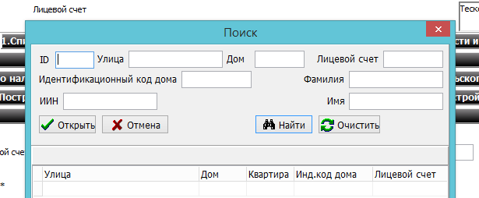
Data search is carried out according to the parameters:
- ID;
- Street;
- House;
- Personal account;
- HIC;
- IIN;
- Last name;
- First name.
The user must fill in one or more of the above fields and click on the "Search" button. A list with the search result will open below. To open this or that data, it is necessary to mark the record and click on the "Open" button. To clear the specified parameters, click on the "Clear" button. Search by parameters "Last name", "First name" - you can search both for the whole word as a whole or for a specific part.
The search is carried out in the selected language: Russian or Kazakh.
For example, if you enter the letter "A" in the "Last Name" field, then all records in which the last name begins with the letter "A" will be found.
- Change period / CATO - when you click on this function, a window with the choice of period will open. Changing the period and CATO is described above.
- Check FLC - this function is designed to check data for format-logical control. When clicked, a window will open with the result of the FLC test.
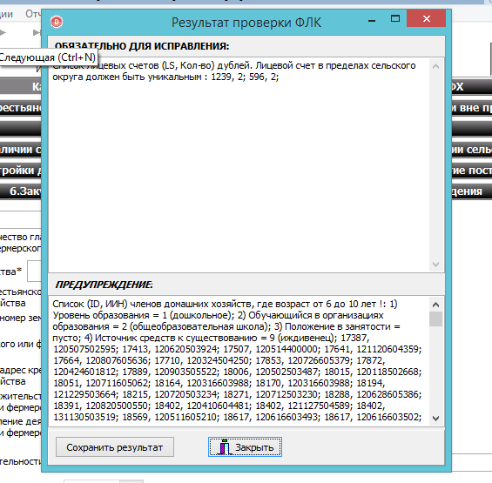
Clicking on the “Close” button will close the window with the result of the FLC check.

- 4) Export to Excel - this function is designed to export data for the rural district to an Excel spreadsheet. When this function is selected, the following fields are unloaded:
According to H.H.:
- CATO code;
- the name of the settlement;
- account number;
- street name, house number, apartment number;
- full name of head of household
According to PFF:
- CATO code;
- the name of the settlement;
- BIN code;
- RNN code;
- name of the PFF
- full name of the head of PFF.
When you click on the button a window will open indicating the location to save the file.
- Creating a selection - this function is designed to save primary information. When clicked, a window for creating a slice will open.
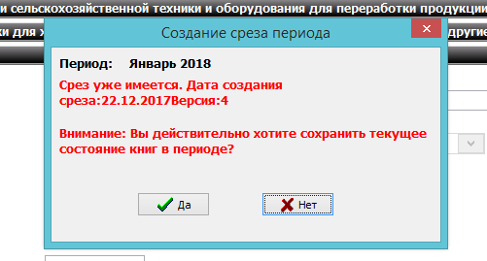
When you click on the "Yes" button, the system will display a message about the successful creation of the selection.
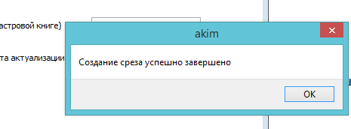
- Export - this function is designed to export data to a specified location, for further transfer to the district statistics department. Clicking on this function will open the following window:

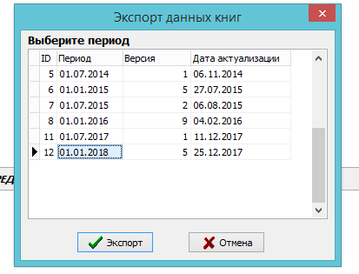
The user needs to select a period and click on the "Export" button. After that, a window will open indicating the location to save the file.
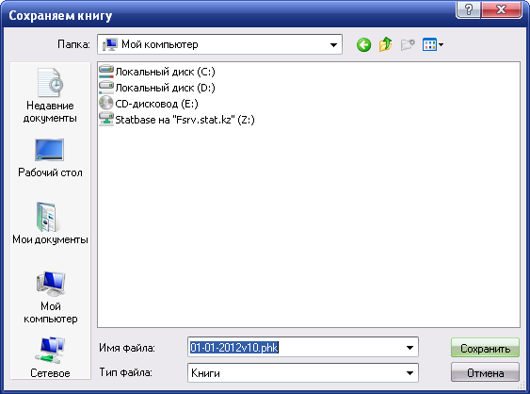
You need to specify the location to save the file and save. A .phk file is generated
ATTENTION! UNTIL THE FLC IS FIXED THE SELECTION WILL NOT BE EXPORTED.
- Theme - the user is given the opportunity to choose a color for the external interface of the program. The program has four colors: standard (gray), green, blue and silver.
- Settings - this function is intended for entering personal data. Setting personal data is described above.
Menu item "Reports"
The Reports menu item is designed to generate statistical forms:
- - “Information on the availability of livestock and poultry, agricultural machinery and buildings in households as of January 1 and July 1 of the reporting year” (index 7-g, semi-annual frequency);
- - "Information on the availability of land in households as of July 1 of the reporting year" (index 7-p, semi-annual frequency);
- - “Information on the availability of livestock and poultry, agricultural machinery and buildings in peasant (farm) farms as of January 1 and July 1 of the reporting year” (index 6-g, semi-annual frequency);
- - “Information on the availability of land and sown areas in peasant (farm) farms as of July 1 of the reporting year” (index 6-r, semi-annual frequency).
- - Other reports.
When you click on a report, the user will open a window with the generated report, with the ability to save, view and print.
The toolbar in the report consists of the following buttons:
 | Начало | Jump to first entry
 | Конец | Jump to the last entry
 | Предыдущая | Jump to the previous record
 | Следующая | Jump to the next record
 | Сохранить | Saving a report
 | Печать | Printing a report
 | Увеличить | Zoom in
 | Уменьшить | Zoom Out
 | Выход | Exiting the mode
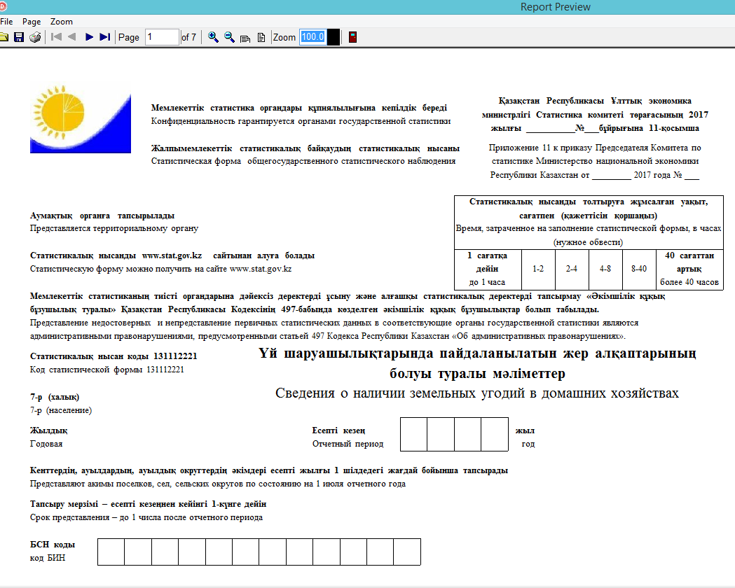
Clicking the button opens the next page of the report.
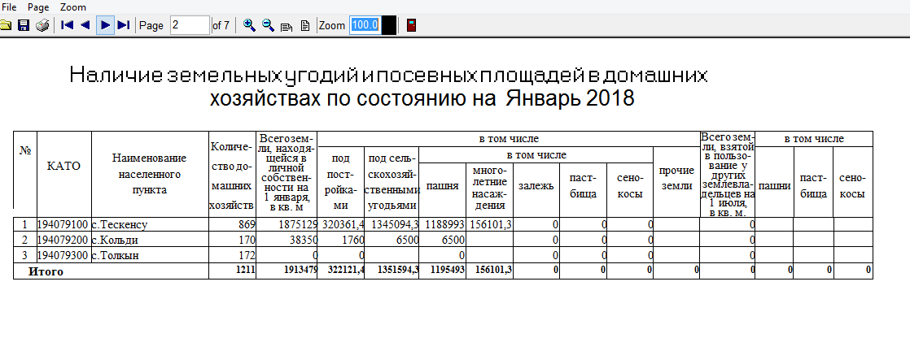
Menu item "Books"
The "Books" menu item is designed to select a book for which the user will enter data. The choice is made by clicking on the desired book. The list displays two books:
- Household ledger;
- Accounting books for peasant and/or farm enterprises.
Menu item "Help"
When you call the “Help” item, a brief instruction on working with the program will open in a separate window.

Menu item "Language"
The "Language" item is designed to change the interface language. The user can choose the interface language: Russian or Kazakh.

Data entry

Data entry is intended for entering primary information on the book of accounting for economic accounting and on the book of accounting for peasant and / or farm enterprises. All incoming data is entered by the operator at the regional level. The book must be selected from the "Books" menu, which is located on the top toolbar.

2.4.1.3.1 Households
To create a new household, press the "Add" button on the toolbar or through the menu item "Data" → "Add".
The Household Data Entry Form has ten tabs and is an exact copy of the paper version of the Household Book:
- Card;
- List of household members;
- Housing conditions;
- Agriculture;
- Livestock, which is the personal property of the farm;
- Agricultural machinery and equipment for processing;
- Buildings for agricultural purposes;
- Additional information.
Tab "Card" - is intended for entering the following fields:
- Personal account;
- Street;
- House;
- Apartment;
- Identification code of the house;
- Number according to the land cadastral book.
Required fields are marked with an asterisk.
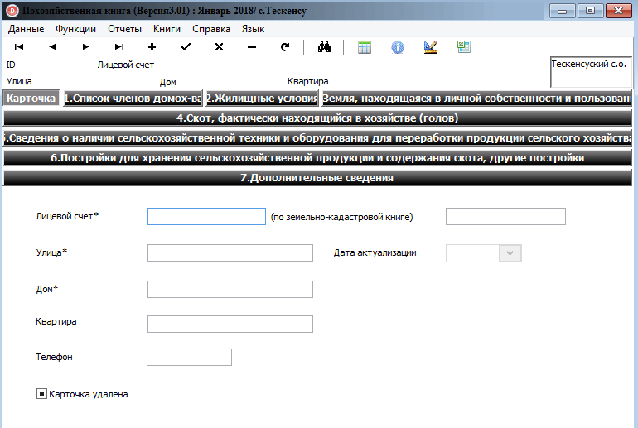

Interline and intersection FLC function in the program. In case of incorrect entry or if a required field is not filled in, the System will display a message indicating the fields not filled in.
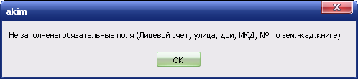
After the user fills in the household card, you must click on the "Save" buttonwhich is located on the toolbar. If the user forgot to click on the "Save" button and went to the next tab, the system will display a warning message:
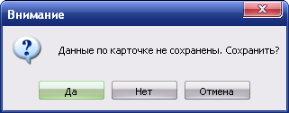
Tab "List of household members" - designed to enter data of household members.
Each tab also has a toolbar:
 | Предыдущая | Jump to the previous record
 | Следующая | Jump to the next record
 | Добавить | Add data for the next household member
 | Сохранить | Save data
 | Отменить | Undo actions
 | Удалить | Delete data for a household member
 | Обновить | Update the data
Required fields are marked with an asterisk.
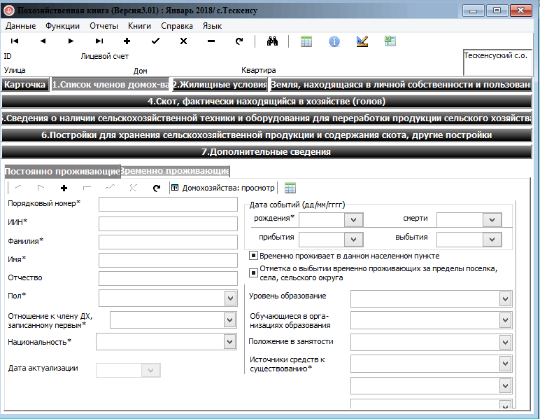
To add the next household member, you must click on the "Add" button which is located on the bottom toolbar.

After entering data for each member of the household, you must save the data using the "Save" button which is located on the toolbar.
The "Living Conditions" tab consists of the following fields:
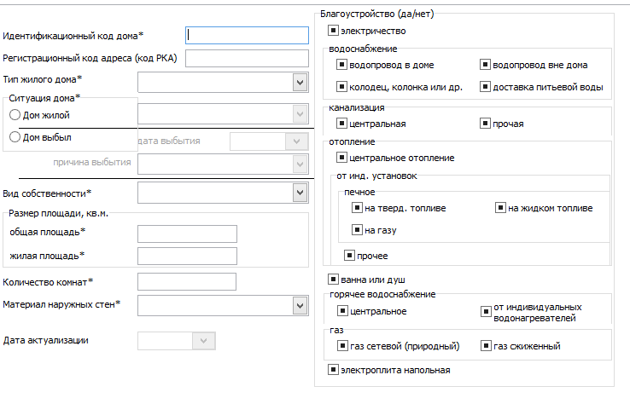

Attention! Tab "Housing conditions" - filled in on January 1, if the user fills in the data for the period of July 1, all fields in the tab will be inactive.
The tab "Land in personal ownership, rented (leased) within and outside the aul (rural), settlement district" is intended for entering data on land, sown areas, etc. The unit of measure for entering land register data in square meters, with one decimal place (0.0).
Attention! For the period of January 1, only those fields that are filled in for this period will be active.
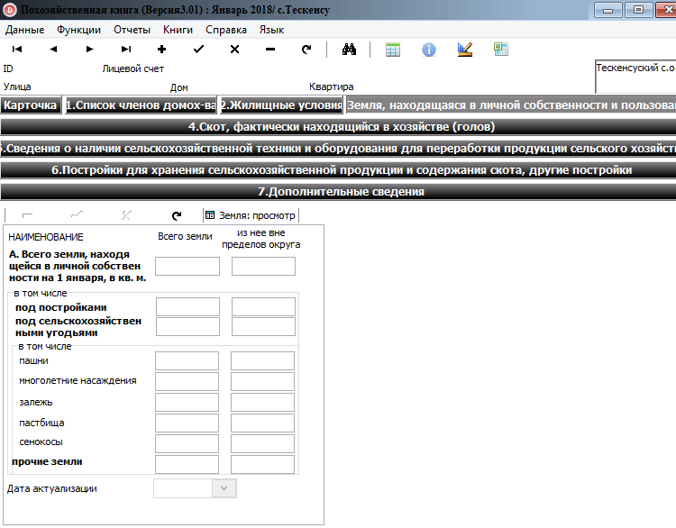
On July 1, these fields will become inactive, only those fields that are filled out for this period will be available to the user.
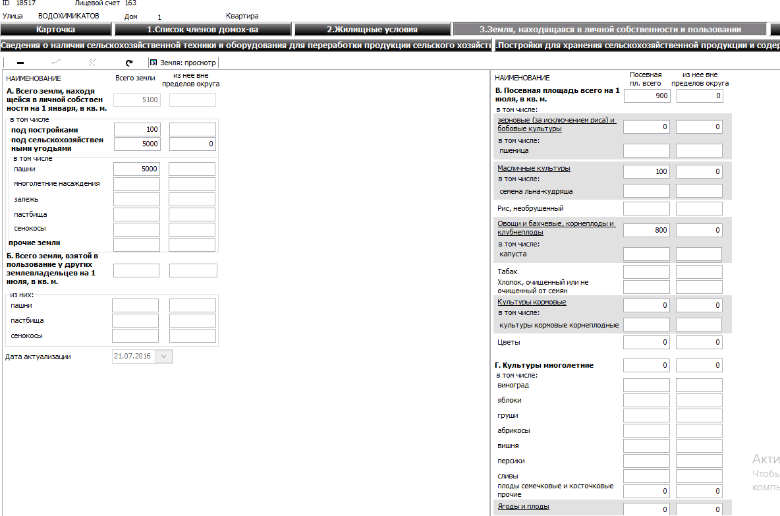
By clicking on the underlined fields, a complete list of grain crops, vegetables, flowers and fruits of pome and stone fruits is displayed. The scroll bar is located on the right side of the window.
After the user enters all the necessary data, it is mandatory to save the data.
The tab "Cattle that is the personal property of the holding" is intended for entering data on the number of livestock, etc.
Clicking on the underlined fields expands the full list of livestock indicators. The scroll bar is located on the right side of the window.
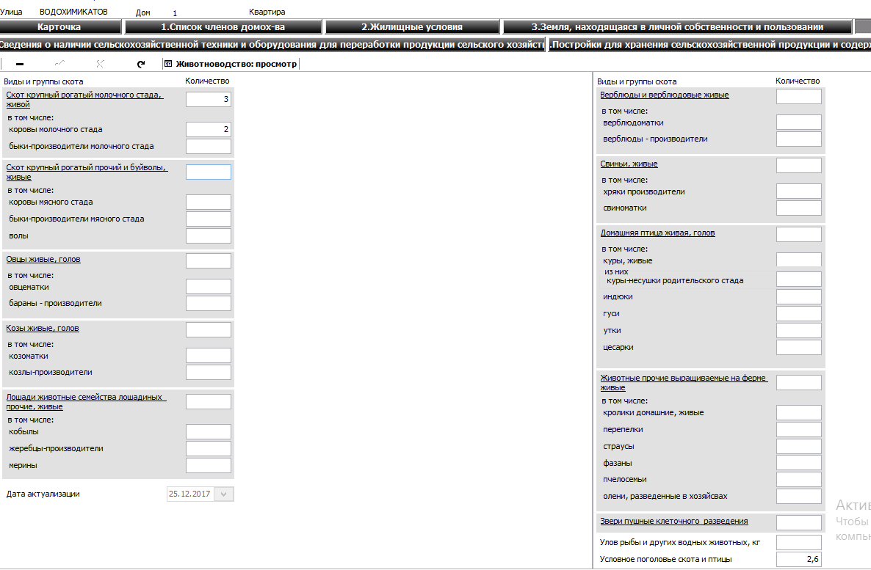
After the user enters all the necessary data, it is mandatory to save the data.
The "Agricultural machinery and processing equipment" tab is divided into two tabs:
- Agricultural machinery by type;
- Equipment for processing.

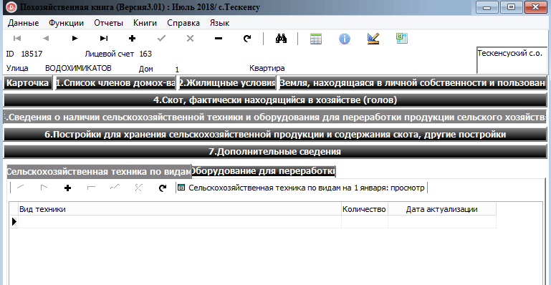

The directory of types of equipment opens in the form of a drop-down window when you double-click on the line. You must click on the arrow and select the desired type of technology.
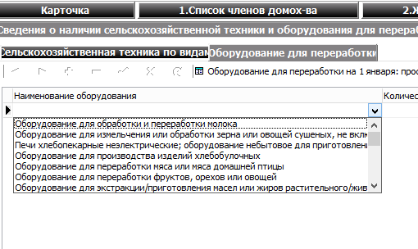
If you need to add another type of equipment, you need to click on the "Add" button on the toolbar.
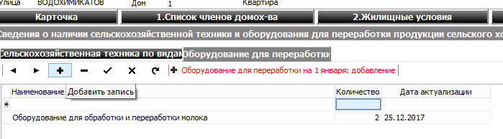
Filling in the "Processing equipment" tab is carried out according to a similar scenario. After entering, you need to save the data using the "Save" button which is located on the toolbar.
- Attention! Information on the types of machinery and equipment for processing is filled in for the period of January 1. For the period of July 1, these tabs will become inactive.
The "Agricultural Buildings" tab is divided into three tabs:
- Buildings for storage of agricultural products;
- Buildings for keeping farm animals;
- Greenhouses.
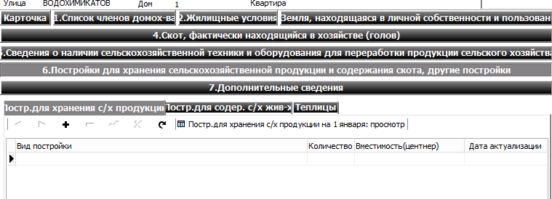
The directory of types of buildings opens in the form of a drop-down window when you double-click on the line. You must click on the arrow and select the desired type of technology.
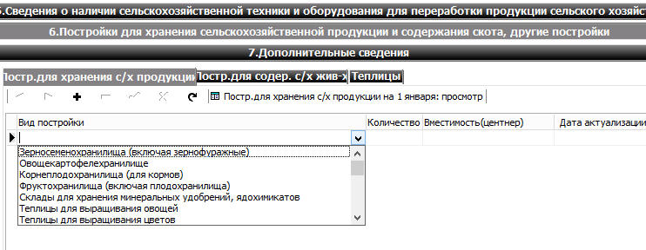
If you need to add another type of building, you need to click on the "Add" button on the toolbar.
Filling in the tab "Buildings for keeping farm animals" is carried out according to a similar scenario.
The fields of the "Greenhouses" tab are filled in manually by the user.
After entering, you need to save the data using the "Save" button which is located on the toolbar.
Attention! Information on the types of buildings and greenhouses is filled in for the period of January 1. For the period of July 1, these tabs will become inactive.
The "Additional Information" tab is filled in manually by the user.
The fields are filled in manually. If you need to add another line, you need to click on the "Add" button on the toolbar..
After entering, you need to save the data using the "Save" button which is located on the toolbar.

2.4.1.3.2 Peasant and/or farming households

To enter data on the Book of Accounting for Peasant and/or farming households, you need to select the appropriate book from the “Books” menu.
Entering data on the Book of Accounting for Peasant and/or farming households is carried out according to the same scenario as entering data on the Book of Economic Accounting, which is described above.
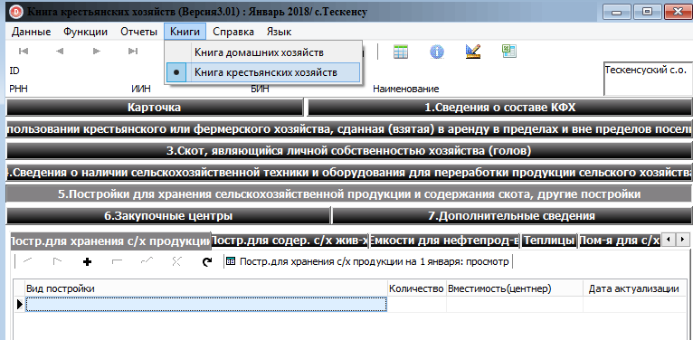

Creating a selection and exporting data.
After the user has entered all the data for the Book of Economic Accounting and the Book of Accounting for Peasants and / or Farms, it is necessary to create a slice and export the book to the place indicated by him.
Creating a selection - this function is located in the "Functions" menu item and is designed to save primary information. When you click on this function, a window for creating a slice will open.

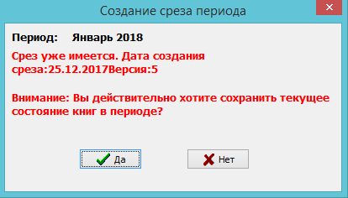
When you click on the "Yes" button, the system will display a message about the successful creation of the selection.
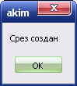
After successfully creating a selection, the user needs to export the workbook.
Export - this function is designed to export data to a specified location, for further transfer to the district statistics department. Clicking on this function will open the following window:

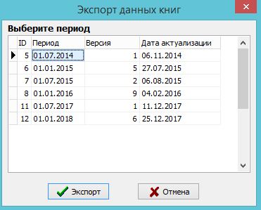

The user needs to select a period and click on the "Export" button. After that, a window will open indicating the location to save the file.

